A turbo jet flies with a velocity of 280 m/s at an altitude where the air is 35 kPa and -40⁰C. The compressor has a pressure ratio of 10 and the temperature of the of the gases at the turbine inlet is 1100 K. Air enters the compressor at a rate of 45 kg/s.
Using cold air standard assumptions and with the aid of the T-s diagram provided, determine:
(a) the temperature and pressure at the turbine exit,
(b) the velocity of the gases at the nozzle exit,
(c) the propulsive force (thrust)
(d) propulsive efficiency
Assumptions:
• isentropic processes
• w-turbine = w-compressor
• cp=1.005 kJ/kgK and γ=1.4
• Internal kinetic and potential energies are negligible
• V2 ≅ 0 (i.e. ideal intake) and V5 ≅ 0

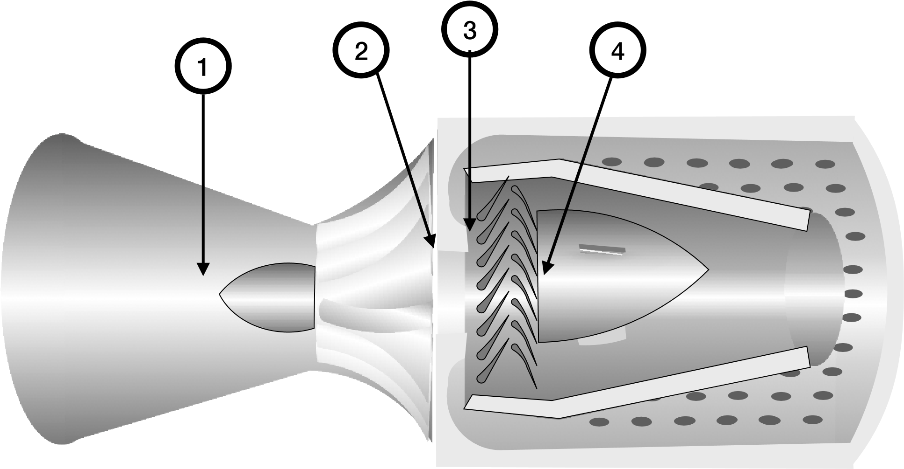

By: Bupe Chapula
Part 1- Experiment
